**PRATICAL 9:**

**ShopEase Online Discount**

**Code:**

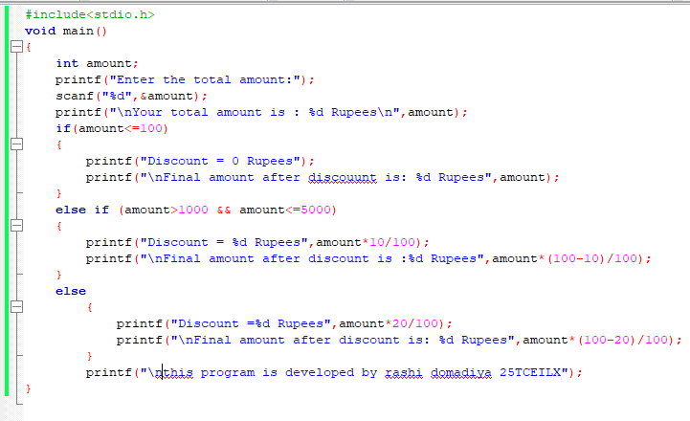

**Output:**

1. **When the amount is less than 100:**

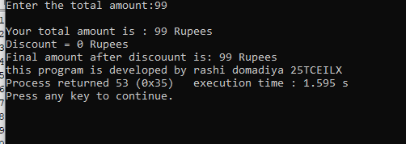

1. **When the amount is less than 1000:**

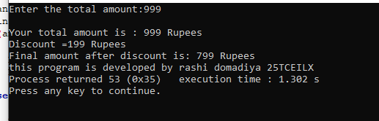

**3)when the amount is more than 5000:**

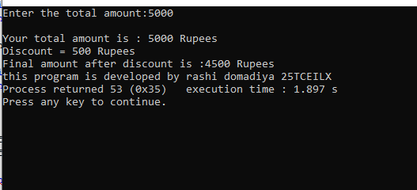

**4)When the amount is 10000:**

